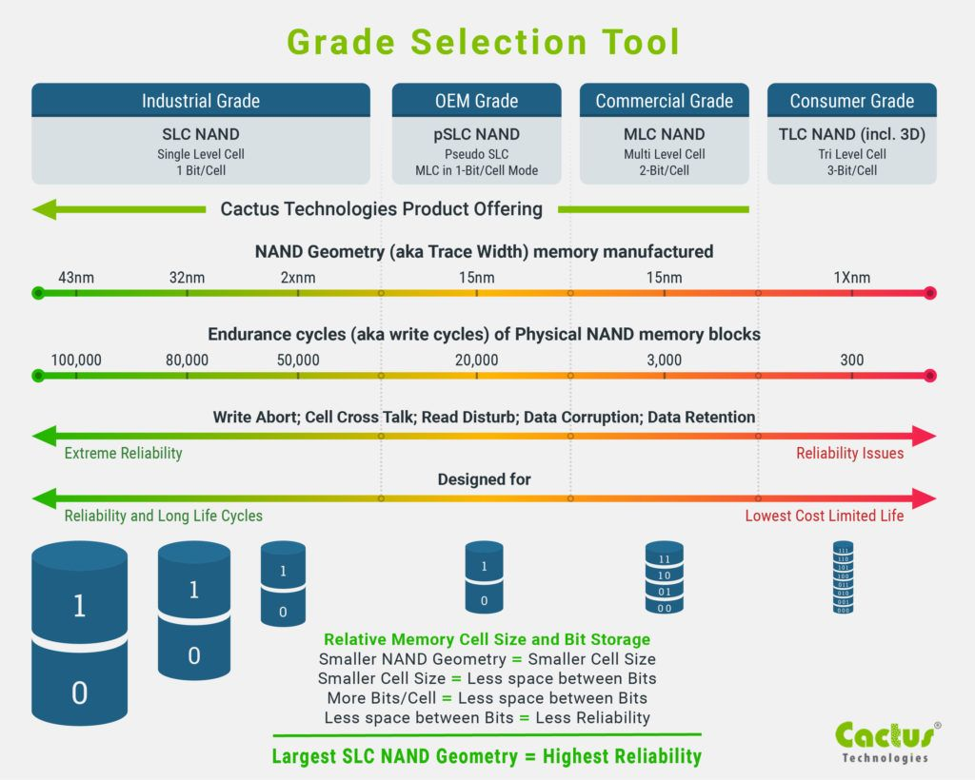

¿El tamaño del ssd afecta a su tiempo de vida?
This is true, and it was one of the key motivation to backing the switch from SLC (fast and durable flash cells, but small capacity) to MLC (slower and less durable flash cells, but bigger capacity). To give you some ballpark numbers (on old 34nm tech):
- SLC drive: 100K P/E cycles (program-erase cycles), 100 GB in size, 10 DWPD (Drive Writes Per Day) x 5y, total 1825 TBW (TeraBytes Written);
- MLC drive: 30K P/E cycles, 200 GB in size, 3 DWPD x 5y, total 1095 TBW.
As you can see, while the MLC drive as less than 1/3 the P/E endurance, due to its bigger size, its total endurance (in Terabyte Written) is 60% of the SLC drive (rather than the expected 30%). An even higher endurance can be achieved with sufficient overprovisioning, bringing relative parity between the two disks.
That said, SSDs rarely die due to NAND wear. Rather, controller and FLT (flash translation layer) bugs are what kill, or brick, flash-based solid state drives. Choosing an SSD, I would put a priority on these things:
- capacity: as space is never enough, do not underestimate your needs. Bigger disks are (often) also faster than smaller ones, due to more NAND chips available;
- power loss protection: if used for synchronous writes, be sure to buy a disk with powerloss protected writeback caches;
- vendor track record: if used for enterprise workloads, do not buy "no-name" SSD or "game oriented" models. Rather, go with a know and reliable vendor, as Intel, Samsung, and Micron/Crucial.

Hablar de 3D NAND y 2D.

Discos duros industriales MLC, SLC… otras marcas “no famosas” como innodisk.

https://www.delkin.com/blog/comparing-2d-nand-vs-3d-nand-ssd/

